Standard Operating Procedure

|  |  |  |  |
| --- | --- | --- | --- |
| Document Name: |  | Version: | 1.0 |
| **Authorized by:** |  | **Date:** |  |

**Revision History**

|  |  |  |  |
| --- | --- | --- | --- |
| **Rev #** | **Release Date** | **Updated by** | **Reason for Update** |
| 1 |  |  |  |
|  |  |  |  |
|  |  |  |  |
|  |  |  |  |

Website is

<https://clvcccuc01a/cuadmin/home.do>

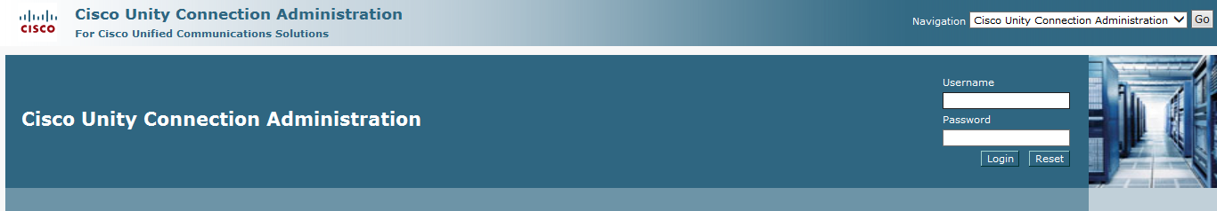

Enter your credentials and login to CUCM to see the home page

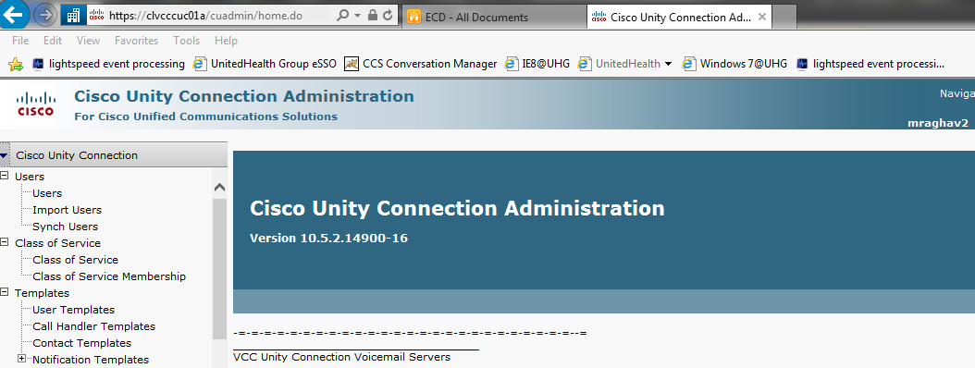

Click on Users to check for the voicemails listed.

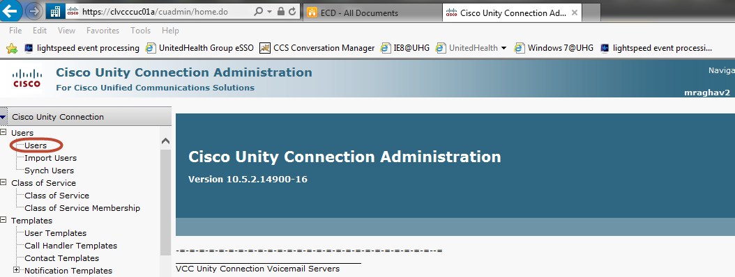

Select the voicemail which you need to send notification to.

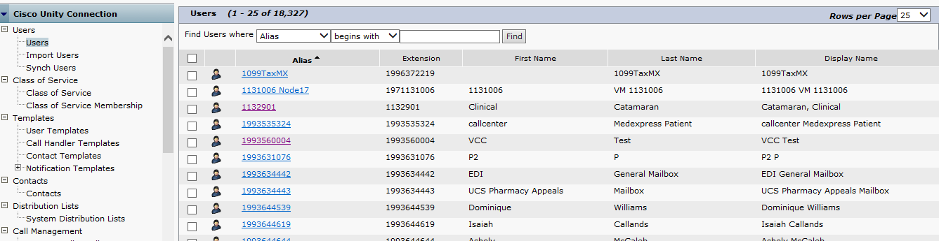

Select it and go to the edit tab you see in the above tab

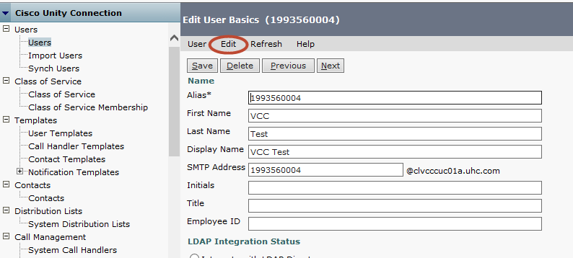

Select the Notification Devices option

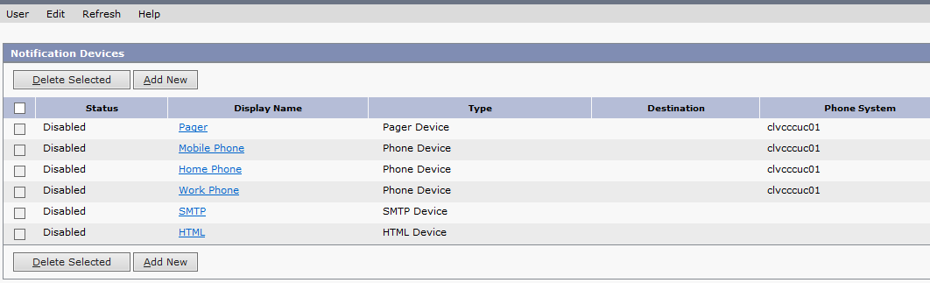

Click on the Add New button to select which type of voicemail notification needs to be sent to the end user

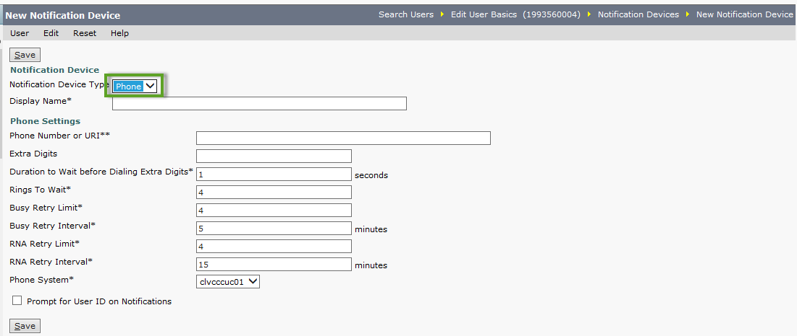

Fill the appropriate fields with the appropriate details.

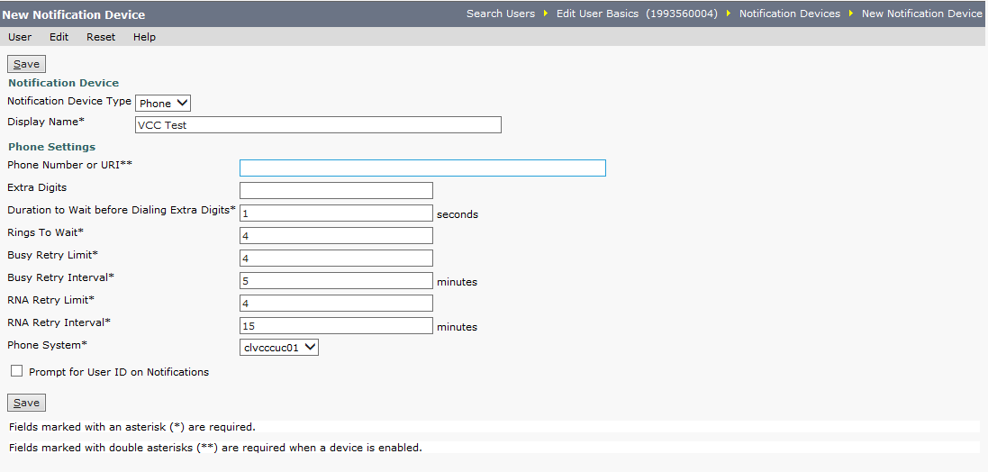

Click on the Save button after you enter the details.

After we create a new Notification device the entry is in Disabled state by default.

Hence we need to click on the one we created and enable as shown below.

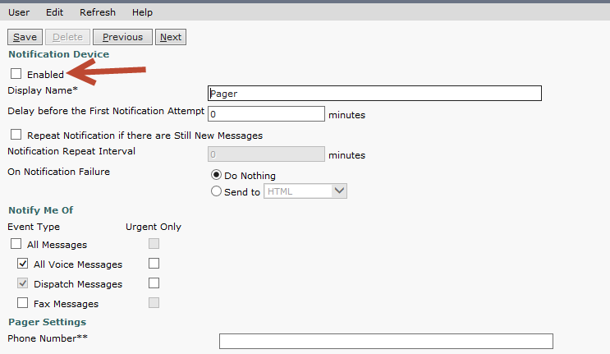

Hit the Save button and we will see that the new entry will be in enabled state.